MODULE:2 INSTALLATION AND MAINTENANCE OF HARDWARE AND ITS

SECTION:1 Multiple Choice

1.**Which of the following precautions should be taken before working on computer hardware?**

* **Wear an anti-static wrist strap to prevent electrostatic discharge.**

2. What is the purpose of the thermal paste during CPU installation?

* To prevent the CPU from overheating.

3. Which tool is used to measure the output voltage of the power supply unit (PSU)?

* Multimeter.

**4. Which component is responsible for storing BIOS settings, such as date and time , even when the computer is powered off?**

* **CMOS battery.**

**SECTION:2 TRUE OR FALSE**

**5. TRUE OR FALSE: When installing anew hard drive, it is essential to format it before use.**

* **TRUE**

6. TRUE OR FALSE: A POST(Power-On-Self-Test) error indicates a problem with the CPU.

* TRUE

7. TRUE OR FALSE: It is safe to remove a USB flash drive from a computer without ejecting it first.

* FALSE

SECTION:3 SHORT ANSWER

8. Describe the steps involved in installing a new graphics card in a desktop computer?

* Power down and unplug the computer.
* Open the case using screwdriving.
* Remove the old GPU if present and by unscrewing & unlocking if from the PCLE slot.
* Insert the new GPU into the PCLEx16 slot until it clicks into right place.
* Secure the card with screw & connect any required power cables from PSU(Power System Unit).
* Close the case & plug the system back in.
* Bootup & install the GPU manufacturer’s website.

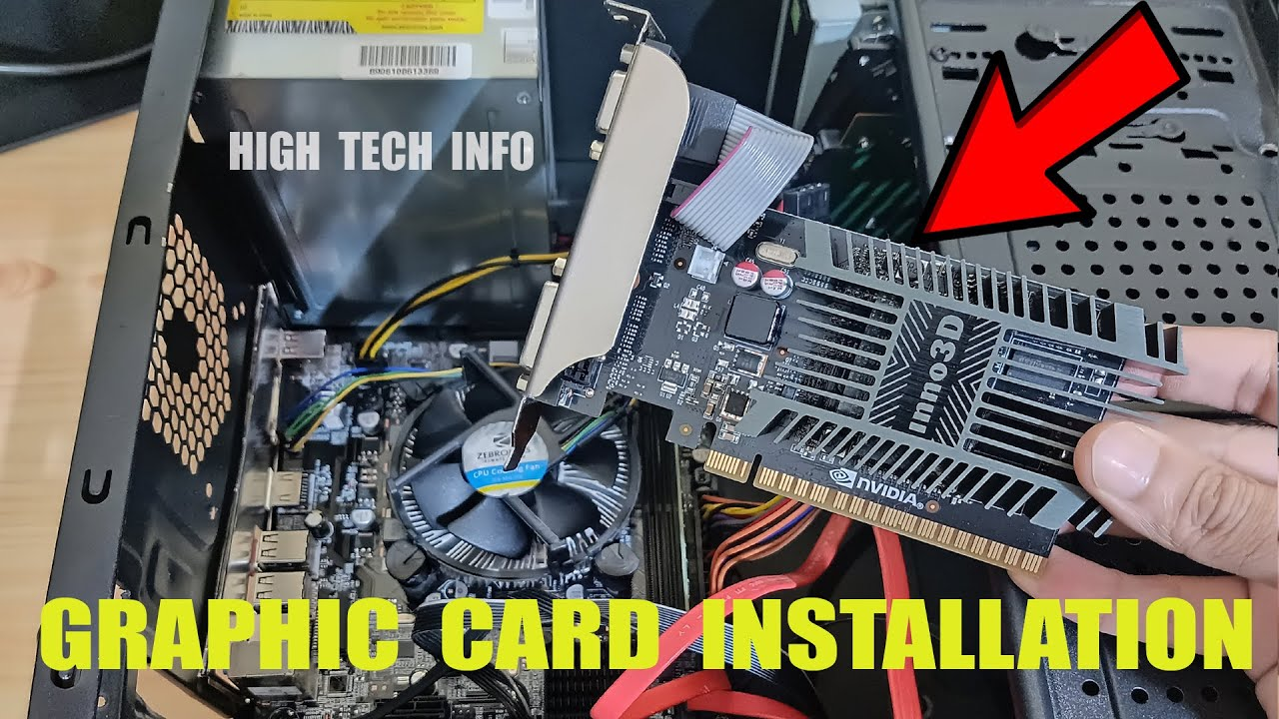

9.What is RAID, and what are some common RAID configurations?

* RAID (redundant array of independent disks) is way of storing the same data in different places on multiple hard disks or solid-slate drives (SSDs) to protect data in the case of a drive failure. There are different RAID levels, however, and not all the have the goal of providing redundancy.

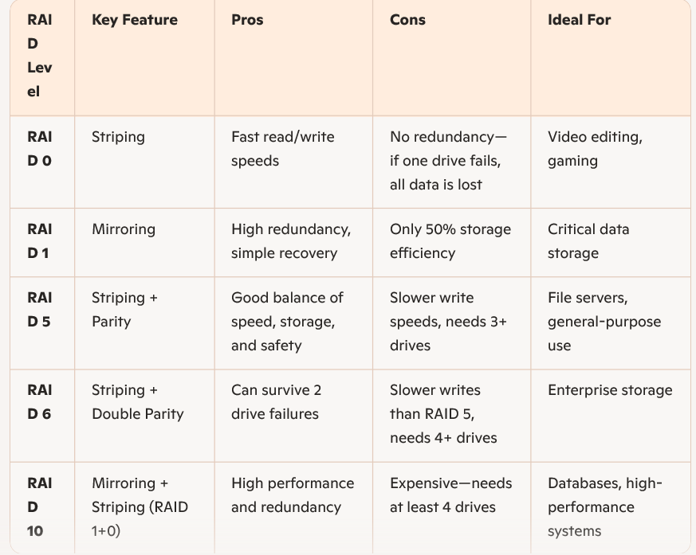

**SECTION:4 PRACTICAL APPLICATION**

**10. Demonstrate how to replace a CPU fan in a desktop computer?**

* **Here some steps how replace CPU fan.**

**What You’ll Need**

* **A compatible replacement CPU fan**
* **Thermal paste**
* **Isopropyl alcohol (90% or higher) and lint-free cloth or Q-tips**
* **A Phillips-head screwdriver**
* **Anti-static wrist strap (optional but recommended)**

Step-by-Step Instructions

* + **Power Down and Unplug**

Shut down your PC and unplug all cables.

Press the power button for a few seconds to discharge any residual electricity.

* Open the Case

Remove the side panel of your desktop case using a screwdriver.

Find the CPU cooler attached to the motherboard, usually near the center.

* + Disconnect the Fan Cable
  + Unplug the fan’s power cable from the CPU_FAN header on the motherboard.
    - Remove the Old Fan

Depending on the cooler type:

* + Stock Intel/AMD coolers

Release the retention clips or unscrew the mounting bracket.

Gently twist the cooler to break the thermal paste seal, then lift it off.

* + - Clean the CPU Surface

Use isopropyl alcohol and a lint-free cloth to clean off the old thermal paste from the CPU.

* + - Apply New Thermal Paste

Apply a pea-sized dot of thermal paste to the center of the CPU.

* + - Install the New Fan

Align the new cooler with the mounting holes.

Secure it using the provided clips or screws.

Plug the fan cable into the CPU_FAN header.

* + Close the Case and Power On

Reattach the side panel.

Plug in your PC and power it on.

Enter BIOS (usually by pressing DEL or F2) to check that the fan is detected and spinning.

SECTION:5 EASSY

**11. Discuss the importance of regular maintenance for computer hardware and provide examples of maintenance tasks.**

Keeping computer hardware in top shape is like giving your car a tune-up—neglect it, and performance suffers. Regular maintenance ensures:

* **Longevity:** Components last longer when they're clean and cooled.
* **Performance:** A well-maintained system runs faster and smoother.
* **Prevention:** Catching potential issues early can save money and avoid crashes.
* **Security:** Removing unused devices and updating firmware helps keep threats at bay.
* **Here some examples of maintenance tasks.**

**1.** Cleaning and Dust Removal

* Use compressed air to clean dust from fans, vents, and keyboards
* Wipe down the monitor and mouse with a lint-free cloth
* Clean inside the case every 3–6 months to prevent overheating

2. Checking and Replacing Components

* Inspect cables and connectors for wear or damage
* Test the battery health on laptops and replace if needed
* Monitor hard drive health using diagnostic tools

3. Updating and Optimizing

* Update firmware and drivers for hardware components
* Run system diagnostics to check for performance issues
* Optimize startup programs to reduce boot time

4. Preventive Measures

* Use surge protectors to avoid electrical damage
* Ensure proper ventilation to prevent overheating
* Back up data regularly in case of hardware failure